Practical Lab 2
The tasks below aim to challenge your fundamental understanding of program design, in particular, exploring how to use variables and how to populate and utilise these variables via input and output functions within Python. You may find that you are unable to finish all 7 tasks during the scheduled practical lab session. This is to be expected at this early stage of the module, however, you are strongly encouraged to complete all tasks in your own time over the course of the next two weeks. These labs provide you with the necessary practice to prepare you for future practical lab sessions and will support you to undertake the module CW.

Access the slide deck & recordings provided for Week 2, to support you with these tasks. You may additionally choose to consult the recommended textbook and to seek out the additional web resources, highlighted in Week 1. Please attempt tasks yourself prior to seeking support from one of the Lab Tutors, however, do make sure to seek support if and when you require it. When seeking support, ensure you ask GOOD questions.

Tasks
- Write a Python code that prompts the user to enter his/her height and assigns the user’s input to a variable named height. Then, output the value stored in the variable, i.e. the user’s entered height.

Your program should look this when run:
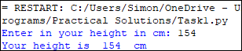

SIDE TASK: expand your program to perform a simple BMI calculation.

- Design a flowchart (on paper or using a program of your choice) for a new program that obtains an item's original price before outputting the sale price, which applyies a 20% discount. Once this is completed, convert your flowchart into pseudo code.

  - Implement your pseudo code as a new Python program. Note: you should aim to output the sales price to two decimal places.

Your program should look something like this when run:

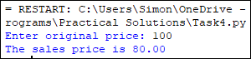

- Write a new Python program that calculates the volume and perimeter of a box. Assume your user will enter parameters in whole numbers for height, width, and depth. Your program should output the perimeter 4 * ( height + width + depth) and volume (height * width * depth) of the box.

Your program should like this when run:

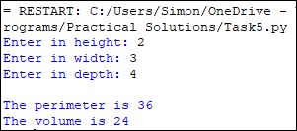

- A company has determined that its annual profit is typically 23% of total sales. Write a new Python program that asks the user to enter the projected amount of total sales, then displays the profit that will be made from that amount (Hint: use the value 0.23 to represent 23%).

Your program should look something like this when run:

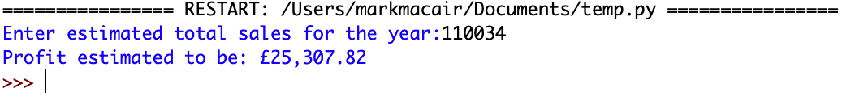

- Assuming there are no accidents or delays, the distance that a car travels down the motorway can be calculated with the following formula:
Distance = Speed x Time

Consider that a car is traveling at 60 miles per hour. Write a program that displays the following:
- The distance the car will travel in 5 hours
- The distance the car will travel in 8 hours
- The distance the car will travel in 12 hours

Note that a Constant must be used in this program.

Your program should look something like this when run:

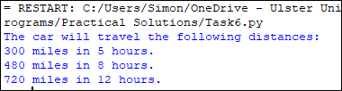

SIDE TASK: modify your program so that the user is requested to input the average travelling speed in mph.

- A car’s miles-per-gallon (MPG) can be calculated with the following formula:
MPG = Miles driven / Gallons of fuel used

Write a program that asks the user for the number of miles driven and the gallons of fuel used. The program should calculate the car’s MPG and display the result.

Your program should look something like this when run:

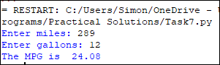

- Last month, Joe purchased some stock in Electric Ireland. Here are the details of the purchase:
- The number of shares that Joe purchased was 1,000.
- When Joe purchased the stock, he paid £32.87 per share.
- Joe paid his stockbroker a commission that amounted to 2% of the amount he paid
for the stock.

Two weeks later Joe sold the stock. Here are the details of the sale:
- The number of shares that Joe sold was 1,000.
- He sold the stock for £33.92 per share.
- He paid his stockbroker another commission that amounted to 2% of the amount
he received for the stock.

Write a program that displays the following information (review the program flowchart below for a sample solution):

- The amount of money Joe paid for the stock.
- The amount of commission Joe paid his broker when he bought the stock.
- The amount that Joe sold the stock for.
- The amount of commission Joe paid his broker when he sold the stock.
- Display the amount of money that Joe had left when he sold the stock and paid his
broker (both times) and indicate if he made a profit in this venture.
